March 2025 | Tractor Times  “We’re Pulling for You” |  |  |  | MVATP  EDGE&TA  Branch 38
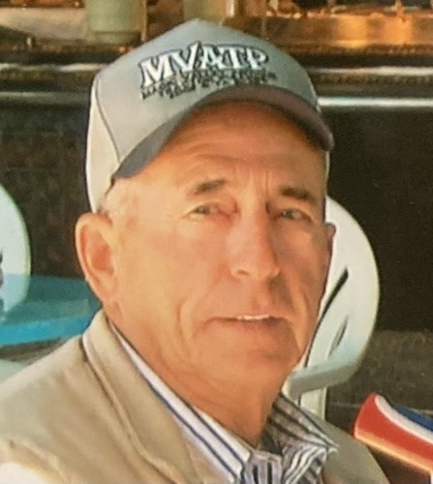
E. Hugh Koonce
Hugh Koonce, a former Camas County resident, recently of Boise, passed away Sunday, February 16, 2025 surrounded by family.
Hugh was born in Soldier, Idaho to Luther and Kathryn (Lilly) Koonce on June 13, 1934. Hugh married Afton (Denny) on November 20, 1955. This union produced three children, Kathy (Gary) of Fairfield, Kevin (Sarah) of Boise, and Karen (Scott) of West Magic. He is survived by two brothers, Paul and Joel Koonce. He was preceded in death by his parents and three sisters, Mary Cluer, Margaret Luther and Ruth Miller. He and Afton have 7 grandchildren (Mandie, Amy, Cody, Tony, Taylor, Colton, Cassie), 11 great grandchildren (Brittany, KC, Daizy, Riley, Ryleigh, Ravyne, Bryson, Madison, Kaige, Tiergan, Maverick) and 3 great great grandchildren (Theodore, Liam, Kaedin).
In the early 50's, Hugh joined the National Guard in Gooding, Idaho, eventually earning the rank of E8 and became a tank commander. He was active in the Camas Soil Conservation District for many years and received the prestigious Doyle Scott Award for "Outstanding Leadership in the Field of Resource Conservation". He and Afton were active in the Camas County Chamber of Commerce - helping to bring the rodeo back to Fairfield and received the Persons of the Year Award in 2008. They served as Grand Marshalls for the Camas County Fair and were also active with the Southern Idaho Tourism Board. (Cont’d Page 2)

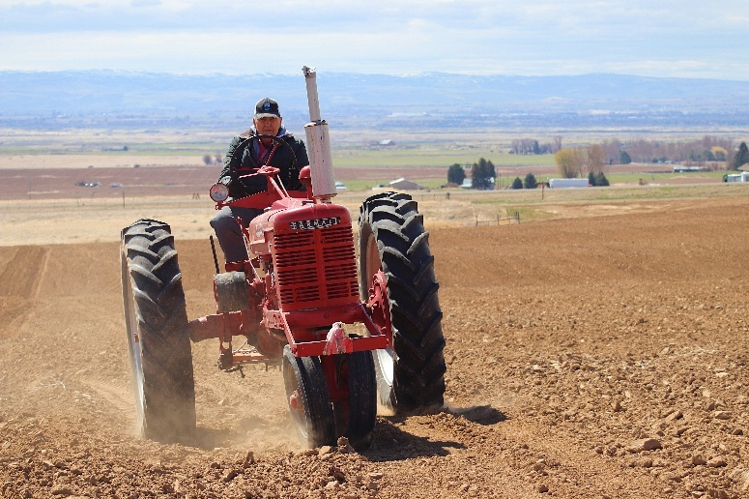
Spring Plow Day at Applewhite’s
Our first event of the year is coming up on Saturday, April 26, at Mark and Patty’s place, 623E 100S, Jerome. Park in the field to the east of the house (don’t use the driveway).
Lunch is a potluck with the main dish provided by the Applewhite’s. Bring a side to share.
This event is open to all EDGE &TA Members. Both Large and L&G Tractors.
  EDGE & TA National  https://edgeta.com/ |  |   MVATP Branch 38  Online at: https://www.magicvalleyantiquetractorpullers.com  Email: MVAntiqueTractorPullers@gmail.com
 |  |  | Page 1

March 2025 | Tractor Times |  |  |  | MVATP
(From Pg 1) Hugh loved the land and worked it with the same strong hands with which he loved his family and tinkered with repairs. He loved farming, ranching, hunting, fishing, snowmobiling, playing cards, spending winters in Yuma and trips to the Oregon coast. Hugh and Afton both enjoyed the time they spent with friends exploring the country sides in their UTV. Hugh enjoyed antique tractor pulls, yard sales and farm auctions. Hugh especially enjoyed pasturing cattle for Colyer Cattle Co of Bruneau. In 2019, upon their retirement, they sold their ranch in Fairfield to Dean Isaac of Bruneau and then moved to Boise.  Hugh never met a stranger: He could walk into any hometown diner, anywhere, and strike up a conversation with the locals, leaving them with the memory of his stories and infectious smile. He and Afton were avid fans at their children's and later the grandchildren's and great grandchildren's sporting events. They served as a vital support for local youth groups, especially 4-H. They were instrumental in gathering add-on monies for the Fat Stock programs.  A Celebration of Life will be held in Fairfield in early summer 2025.As one great grandson said, "Grampa was a warrior. He is in Valhalla."  Cremation arrangements are under the care and direction of Demaray Funeral Service – Gooding Chapel. |  |  | 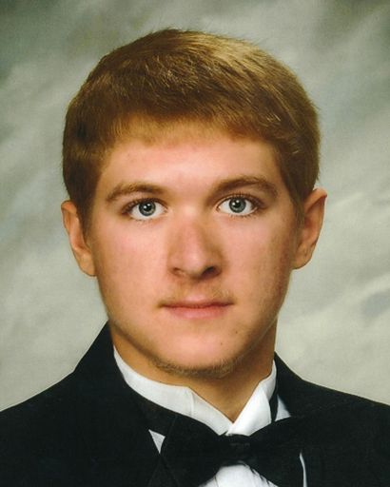  Alex Arrien Taber  May 19, 2004 — February 27, 2025  Alex Arrien Taber, age 20 of Shoshone, ID, passed away suddenly on February 27, 2025, in Moscow, ID, surrounded by family and close friends. Alex was born May 19, 2004, to Chris Taber and Lynda Lezamiz in Twin Falls, ID. He attended Shoshone schools, participated in football and basketball, and graduated with honors in 2022. After graduation, he became a University of Idaho Vandal majoring in Agricultural Systems Management. He had plans to graduate early in 2026, and to continue studies in Aviation Mechanics. Alex’s inquisitive nature made him always ask “how/ why?” He loved learning and was fascinated with “how” things worked. He had a unique gift of impressing his teachers with his witty sarcasm and his curious nature. This classroom interaction would forge special friendships with several of his professors during his college career. (Cont’d Below)
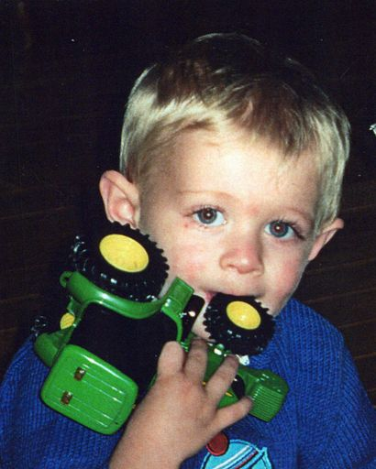
(Taber, Cont’d) Alex possessed a true love for farming. This was evident in the fact that he rarely traveled far from the family farms. He grew up running agricultural equipment at a very young age which often led to amusing commentary by observing neighbors. Noticed as the little kid driving the commanding semi, looking in between the steering wheel, or running a loader like an experienced adult, he became known as the “Blonde Bomber.” However young and cute he looked, he quickly earned respect for his aptitude in taking on responsibilities without the need for much instruction. He enjoyed working in all aspects of farming, whether at the Buena Vista, or at his dad’s custom farm business, his Uncle John’s farm or his Uncle Sid’s excavation business. Everyone enjoyed working with Alex for his work ethic and his teasing nature which always made the work more fun. Nothing made his mom and dad prouder than to hear someone say: “Gosh he’s such a talented kid.” (cont’d page 3)
 |  | Page 2

March 2025 | Tractor Times |  |  | MVATP
(Taber, from pg.2) Alex’s hobbies included horseback riding in his younger years and dirt bike riding in the foothills as he became older. He and his brother, Patrick, along with several friends made time on weekends to ride together and challenge one another. Many videos, great memories, and lifelong bonds were created on these adventures.
Alex is survived by his loving parents, Chris Taber and Lynda Lezamiz; his grandparents, Donald and Beverly Taber all of Shoshone; his brother, Patrick Taber (Marika Versis) of Twin Falls; his half-siblings, Ethan (Tiffany) Taber of Rolla, MO; and Katelin (Nathan) Arnold of Rathdrum, ID; uncles and aunts, Darren (Amie) Taber of Shoshone, ID with cousins, Martin Taber, Moira Taber, and Megan Taber; Matt (Shirlee) Taber with cousins, Cole Davis, Madison Taber, and Hannah Taber; Mary Lou (Cisco) Limbago of Caldwell, ID with cousins, Brandi Limbago and Dan Limbago; John (Bonnie) Lezamiz of Twin Falls, ID with cousins, Brett Lezamiz, Luke Lezamiz, and Jodi Lezamiz; Margaret Lezamiz (John Schroeder) of Boise, ID with cousins, Luci Schroeder-Hart and Paul Schroeder; Sid (Ricki) Lezamiz of Twin Falls, ID with cousins, Midauti Lezamiz, Kelsey Fairfield, Karson Wright, and Joe Lezamiz; Robin (Karen) Lezamiz of Richfield, ID with cousins, Matthew (Ashley) Lezamiz, Michael (Parris) Lezamiz, and Mariah Lezamiz.
Alex was preceded in death by his maternal grandparents, Ciriaco (Sid) and Luchy Lezamiz.
Funeral service will be held at 11:00 am, Saturday, March 15, 2025, at The Church of Jesus Christ of Latter-day Saints, 1228 S. Main St, Gooding, ID, followed by a Celebration of Life at the Gooding Basque Center, Gooding, ID.
In lieu of flowers, memorial donations may be made in Alex’s name to the Gooding Basque Association, PO Box 517 Gooding, ID. 83330.
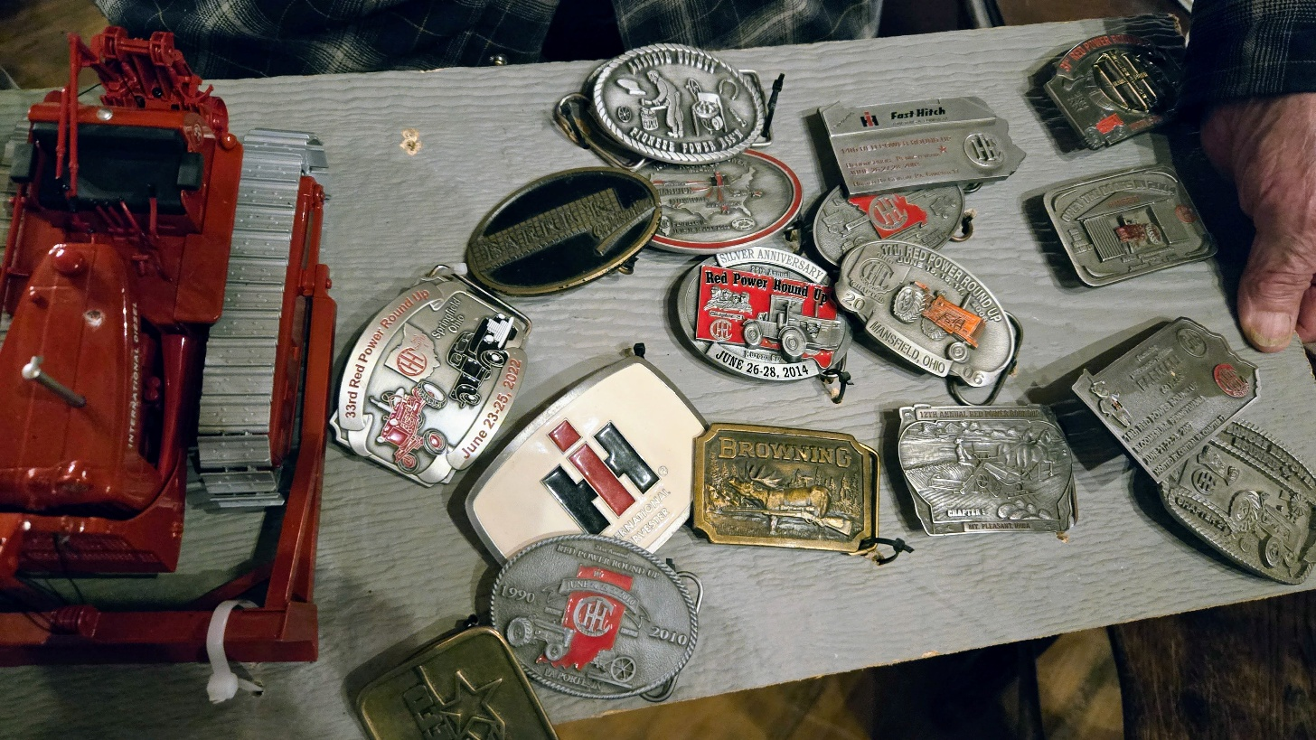
Show ‘n’ Tell
Al Barkl shared this really neat collection of belt buckles to share. Al collected these from the Red Power Round over the years.
Red Power Round-up is an annual event featuring International Harvest.
Scholarship recipients will be attending our March Meeting.
Come celebrate the achievements of these deserving young people

 |  | Page 3

March Mtg: Thurs 3/27 @ Mtn View Barn, Jerome/
Meal 7:00pm, Mtg 7:30pm
Spring Plow Day at AppleWhite’s 4/26
Magic Valley Antique Tractor Pullers
c/o Cassie Duchow
3682 N 2500 E
Twin Falls, Idaho 83301

